Spatializing Harriet Bell: Placemaking and Installing Legacies as a Free Black Woman in Vienna, Virginia

Annabelle Spencer
HIST 615 Antebellum African American Women’s History
Dr. Yvette Richards
15 December 2024

Standing in the sun, before a wooden fence and the side of an old house, framed by the shadows cast by blooming trees to her right and left, is a woman. Her hair is tied up in a small bonnet at the back of her head and she has draped herself in a short cape fastened at her neck. Her shoulders are turned slightly to the right, away from the camera, and she does not look into the lens. The woman is centered in the photo, directly in front of a white-washed brick chimney, as if to maximize the contrast between her skin and the environment. She is the focus of the photographer, and yet, she is unnamed. Over a century later, a newspaper published the photo with the following caption: “An early photograph of the John Follin home in Vienna shows a servant before a side view of the house.” Left unsaid is the fact that she was not a servant, but instead an enslaved woman, and that at the time this article was published, her descendants, not the Follins, owned the land shown behind her. The woman’s name is Harriet Bell, and this is her story.
Harriet Bell was born around 1830 to a father named Starling Bell and a mother whose name is unknown on the Follin Plantation in what is now the town of Vienna in Fairfax County, Virginia. She grew up and had children while enslaved, held specifically under the dominion of Mary Follin, the white widow of John Follin who held claim to what was left of the plantation in the years leading up to the Civil War. Bell’s time in bondage and her identity as an enslaved girl and woman was defined by the spaces she could and could not go, the spaces she was forced to work, the idea that her body was space, and the spaces she dreamed of inhabiting. Both under enslavement and eventually in freedom, Bell was creative and intentional about responding to the brutality that she faced and redefining her sense of self through placemaking. Through the ownership and use of space, both personally and communally, Harriet Bell installed powerful legacies for her children that could never be erased. These legacies she installed connected her future generations with education, religion, society, property, and a pride in where they came from. Similar to the meaning behind the photograph that was taken of her, much of the placemaking Bell engaged in during her life, and even in death, is now hidden from view, but with careful attention, her installed legacies can be removed from invisibility.
When Place Was Decided for Her
Bonded labor of enslaved people in the American South was often gendered, meaning that work such as housekeeping, sewing, and personal service to enslavers was often coded as feminine. Therefore, enslaved men were less likely to be tasked with these sorts of assignments which usually took place within the plantation home. Instead, most enslaved men were relegated to work out of doors doing more physical labor in the fields. Contrary to this traditional understanding, these binary roles did not always hold true. Some enslaved men did perform domestic work, but a more frequent departure from gendered labor occurred with enslaved women. Instead of swapping domestic for physical, many enslaved women served double labor duties, both in the house and in the field. While Follin family history claims Bell was gifted to Mary Follin as a “house girl and her maid,” other testimony complicates this image of demure and feminine domestic service. Harriet Bell’s oldest son Frank was interviewed by the Virginia Writers’ Project in 1936 and when asked about labor on the Follin plantation, he replied:
“[John Follin] wasn’t much on no special house servants. Put everybody in de field, he
did, even de women. Growed mostly wheat on the plantation, an’ de men would scythe
and cradle while de women folks would rake and bind. Den us little chillun, boys an’ girls, would come along an’ stack. Used to wuk in family groups, we did. Now we and my four brothers, used to follow my mom an’ dad. In dat way one could help de other when dey got behind. All of us would pitch in and help Momma who warn’t very strong.”

It is likely that after the death of John Follin in 1841, Harriet Bell’s tasks did actually make a marked shift away from the physical labor she once was made to perform with regularity. As a widow, Mary Follin ceased much of the planting operations and would not have needed Bell tending to the fields. The inheritance of Follin’s nearly 30 adult children and stepchildren had left her a shell of the domineering mistress she once was. The number of enslaved people under her control dropped to five in 1850, a drastic fall when compared to the sixteen enslaved people who were appraised after her husband’s death less than ten years prior. She still retained nearly 400 acres of land, but without the dozens of enslaved laborers to cultivate and harvest it, her main source of income disappeared. Additionally, Fairfax County was one of many localities in the early to mid-twentieth century whose agricultural economy suffered due to soil exhaustion. This caused a sharp decline in land prices, which in turn, invited the immigration of hundreds of northern families with the capital and agricultural knowledge to navigate the poor soil and turn a profit. As the plantation economy turned towards family sized farms, the market for “hired” labor skyrocketed, providing Follin and many other white widows in similar financial situations with a convenient alternative stream of income. As she began leasing the enslaved people she did own, it is possible that Bell began to primarily work within the house as Follin’s personal “maid.”
Even still, the domestic work Bell performed in the plantation home was never intended to affirm her own femininity, let alone support her motherhood or personal autonomy. She was never paid for her work, and while perhaps not as physically arduous, working inside the Follin home required a distinct psychological toil. The lines between public and private blurred within her workplace in the main house to create a space where Follin fully exploited Bell while simultaneously feigning a closeness between them. Follin’s descendants describe Bell as “devotedly attached to her ‘Missus’ and her family,” claiming also that when Union forces were near the plantation, Bell “refused freedom rather than desert her mistress.” This intragender mythology is not uncommon in Lost Cause style memory, but it could not be farther from the truth. In fact, Bell’s disloyalty, like that of many other formerly enslaved women, would have grave “implications for [the Follins’] southern white identity.”
The only feminine gentility encouraged on the Follin plantation was that of Mary Follin herself, and even in her case, it was at least partially an act. Her distinctly racialized and gendered identity, that she both was born into and crafted herself, necessitated Bell’s relegation to subhuman as her enslaved property. By perceiving Bell as a bonded “personal maid” rather than human being whose life and rights she stole, Follin performed a wealth and status that she, in actuality, did not possess. She was an aging woman who had raised children in the era of what has been called the “sentimental mother,” a prescriptive stereotype of wealthy white women that valued only their domesticity, mothering, and piety. Though no longer raising children, as an elderly woman, Mary Follin likely continued to pursue this identity. However, rather than living with or off any of her children’s incomes, she chose or was forced to live alone in a large empty Antebellum home, living with the money she made from leasing human life. To be certain, the Follin family would not have been considered poor, especially at their economic peak pre-Civil War. Ultimately, though, their plantation was not a place of high society or incredible wealth. Instead, it was a place where that image was crafted through the manipulation of space, both geographical and human, i.e. Harriet Bell herself.
For Bell, the plantation home and property more broadly was a “geography of containment,” and was likely detrimental to family life and child rearing The plantation was where she had her first five children, but there was no space allocated for her to be a mother. That, Bell created herself despite the burdens of her labor. Her children were born into slavery on this plantation between the years 1850 and 1865. Their names were Frank, Randolph, Julius, Lizzie, and Moses. Many new enslaved mothers like Bell were given two weeks away from work after giving birth and then would have to bring their infants into the field to nurse them while being forced to work. Bell and her children are left unnamed on the 1860 slave schedule and yet, this document reveals the spatial oppression that they endured. A total of seven people, aged one to twenty, were enslaved on the plantation at this time, and there was only one “slave house” noted to accommodate them. There was no space intended to be personal or private to them.
With the available sources, it is impossible to know how this one room space felt to Bell as a mother and as a person herself. Any of the ways she engaged in placemaking here, turning the one room geography of oppression into a home for her children, remain silenced. Yet, it is possible to imagine that Bell would have adorned the space with decorations and created as many positive memories for her children as she could have in the place they were forced to call home.
One confirmed method of legacy installation that Bell engaged in under enslavement was naming her children after family members. Much of her genealogy remains a mystery, but she without a doubt had an older brother named Moses. He first appears at 18 years-old alongside twelve-year-old Harriet in the 1841 inventory of John Follin’s property. Their father Starling appears at the end of the inventory, aged fifty two, and is listed as having an “unsound” mind. According to her son Frank’s much later oral history, uncle Moses was made to be an overseer on the plantation, which is why they were allowed to work in family groups. Moses had a wife and two children who were enslaved on another plantation close by, who he would ride a horse to visit every Sunday night. Despite, or perhaps because of, the closeness of him and his family, Moses never gave up on his dream of freedom. Each year when harvest came, he escaped and ran for the north, and each year he was caught. Eventually, the Follins sold him south, possibly to Alabama, and he never saw his family again. It was with love and homage that Harriet named her son after him. The interviewer's notes which accompany Frank’s oral history claim that his father’s name was also Frank, insinuating that Harriet had a husband or partner while enslaved. If this is true, her first born son is another example of how she installed family legacy through naming.
Legacy naming was a powerful form of resistance for enslaved families, as it responded directly to the anonymity so often forced upon them. Systemically made to be property in the wills, deeds, covenants, inventories, tax records, and slave schedules that periodized their lives by moments of sale, ownership, and purchase, left them without surnames if they were even named at all. Bell’s insistence on legacy installation through naming was also a direct response to her specific enslavement by the Follins. Of the roughly thirty children John Follin had between his two wives, a good many of them were named after family members. Bell’s naming practice was not a mimicry of or assimilation to proximal whiteness. Instead, by asserting her motherhood and family lineage in this way, she subtly showed that she and Mary Follin had something in common, thereby disrupting the psychological stratification of her enslaver. More intimate than her basal humanity, Follin would have had to mentally cleave Bell from any kind of mothering identity. This cognitive separation of Bell from the ability to be maternal based on her race, was crucial for Follin’s attempt at justifying her enslavement.
Home Space
The pervasive spatial oppression that Harriet Bell faced as an enslaved woman influenced her identity formation as a free Black woman following emancipation. Her identity construction and legacy installment can be seen in the specific ways she created security and prosperity for herself and her children. Historians and scholars including Kidada Williams, bell hooks, and Earl Lewis have studied the creation of “home spaces” after emancipation where they could safely be together with family. These spaces also served as “the first line of defense” or a separate sphere away from white violence and control. Bell’s creation of home with and without her husband is an expression of this type of placemaking. Directly addressing the ways in which her enslavement, specifically by Mary Follin, stripped her of her perceived maternity, Bell’s placemaking began in freedom as an assertion of motherhood and protection of family.
Soon after 1865, she married a man named Marlow Brown. Brown was the father of her last three children, Laura, Lucy, and Herbert. Lucy was the only one of the three to live to adulthood. The family did not leave Vienna but lived together in a home not far from where the Follin plantation had been. By 1870, the Browns were living together on property Marlow owned, right next door to another Brown family: George “Mack” Brown and Harriet Mallory Brown, of possible relation.
In 1876, Harriet Bell purchased property of her own, a landmark moment in her life. Scholars have found that during this time, property ownership was declining among free Black women, even in the Upper South. Between 1860 and 1870, Black women’s real estate ownership in the South dropped by ten percent, making this acquisition even more remarkable. Harriet may have made this purchase due to the split between her and Marlow. On the deed, she used her maiden name and by 1880, she was living with the children in a separate home in Vienna, presumably on this new property. Additionally, while Marlow lived until 1893, Bell was marked as “Widowed or Divorced” on the 1880 census. As heartbreaking and difficult as this undoubtedly was, the choice of romantic and family partner was also a privilege she had only recently gained the right to exercise. Notably, her children from before Marlow (Frank, Randolph, Julius, Lizzie, and Moses) who had taken Brown as their own surname in 1870, exclusively began to use Bell going forward.
While this property purchase was likely out of necessity and may have marked the beginning of a more difficult chapter of her life as a single mother, it was doubly significant because of the specific acreage she had acquired. The ten acres she became sole owner of had originally been part of the Follin plantation where she had been enslaved. This represented an important reclamation and redefinition of space on a level greater than she had ever done before. Rather than being the property owned by Mary Follin, Bell owned property in her own right. Property that was intended to only benefit the Follin family. This land was no longer the backdrop to her enslavement. Instead, it was the place she chose to raise her family and redefine herself on her own terms, marking her first instance of placemaking as a free and single woman.
Community Placemaking
Even before her divorce and independent property ownership, Bell became involved in her community where she was involved in placemaking on a much broader scale. In September of 1867, Harriet Bell became a founding member of her church, First Baptist Church of Vienna (FBCV). George “Mack” Brown, Bell’s next-door neighbor and possible brother-in-law, was one of the original trustees alongside Daniel and Edmund Harris. First Baptist still stands today as Vienna’s first and oldest church and at its founding, also served as the first school for Black children. Much of the neighborhood on and around the Bells’ and Browns’ street, now Wolf Trap Rd SE, comprised the founding congregation. Their religious fervor was in part ignited by Reverend Cyrus Carter, a locally known spiritual leader who had raised a freedmen’s church in nearby Lincolnville, now McLean. He came to Vienna to support the group and would eventually serve as their inaugural pastor.
After ideating with Carter, the group’s next step was to identify land and create a place of worship. Orrine E. Hine, a former Union Army Major who settled in Fairfax County after the war, employed many of the formerly enslaved men and women in Vienna at his farm and real estate businesses. Leveraging their employment and perhaps more personal relationships with Hine, the group approached him with their dream of building a church. He drew up a deed that, in exchange for one dollar, granted the trustees a parcel of land, stipulating that the structure they built there must be used to host both church and school. If the group did not comply with this dual requirement, the land would revert to Hine or his heirs. Hine then petitioned the Freedmen’s Bureau on their behalf requesting that the Bureau purchase any of the abandoned Civil War cantonments nearby so the congregation could reuse the lumber to construct their new building.
This recycling maneuver was intended to relieve the group of financial strain that could have occurred had they needed to purchase their own material, but it additionally became a poignant act of placemaking. In the creation of their holy place and the first school for Black children in Vienna, they put to use wood that had sheltered soldiers presumably fighting both for and against their basic human rights. This was a transformation of space and material of war into a place of Black success, religiosity, and education, and it marked the beginning of their envisioned community. Endowing the lumber and land with new meaning, the founders of First Baptist of Vienna, many of them formerly enslaved like Bell and her family, physically reframed the Civil War around the legacies they were subsequently installing.
The Bell family’s connection to the church and the school continued, as generation after generation claimed the space as their own. All of Harriet Bell’s children were educated, presumably at the First Baptist Church school, even the oldest Frank who would have been an adolescent when the FBCV was founded. This is a remarkable feat, that just two years following the Civil War, formerly enslaved children were being formally taught to read and write. It is remarkable, but not surprising since it is a direct result of their parents’ advocacy and insistence on installing meaningful legacies of education and success for their children; Legacies specifically installed through the use of space. In 1935, her grandchildren and other descendants, including Rosure Bell, Eliza Bell, Charles Jackson, Mamie Bell, Lillie Bell, and James A. Carter, were listed as active members of the congregation and regularly paid tithe, continuing the interdependent nature and investment culture of Vienna’s Black community, specifically at First Baptist.
The other community group Bell was a founding member of is indicated by her final resting place: the Sons and Daughters of Liberty cemetery on Orchard Street in Vienna. She lies there, in a plot with and nearby many of her children and grandchildren. This cemetery, now owned by First Baptist Church of Vienna, was originally husbanded by the Grand United Order of the Sons and Daughters of Liberty lodge no. 9, a separate fraternal organization to which she belonged. The lodge was part of a much larger organization, with many branches nationwide. Many African American lodges and secret societies like Sons and Daughters of Liberty were organized and established in the aftermath of the Civil War as mutual aid societies that served the needy and destitute, while also providing social events and gatherings.
The Sons and Daughters of Liberty lodge in Vienna called many different spaces home in the years they were active, many of them due to religious partnerships. According to a community member’s recollection, the Vienna branch’s early meetings were held at Shiloh Baptist Church once their building was officially dedicated in 1891. Over the next two years, Sons and Daughters purchased two pieces of property: one for a cemetery, and the other to build a meeting hall of their own. In 1904, the lodge’s meeting place came to the aid of the local religious community, when First Baptist Church split in two. Half of the congregation, worried about losing claim to their land, wished to construct a new building on a property free from Hine’s decades old stipulation regarding education. Others, including the Bells, were content remaining in that original church. As a result, several congregants led by elder Andrew Minor, also founding trustee of Sons and Daughters, struck out on their own and founded Union Baptist Church. Union rented the Sons and Daughters’ meeting hall until 1906 when their new worship space was finished. Perhaps to pay a debt of gratitude, Union also constructed a brand new two-story building just next to their inaugural church for the Sons and Daughters lodge to use. In reporting Union’s official activation, the Fairfax Herald described the partnered lodge as “a flourishing society” that would hold their regular meetings in this somewhat shared space going forward. The interdependence of the Sons and Daughters lodge with the Black community in Vienna, particularly the churches, is therefore reflected in their use of space. The lodge at different times existed nomadically and as a symbiotic partner, because the most important part of the group was not the space in which they met, but rather the meaningful place they created anywhere they were with their members and the people they served.
Sons and Daughters’ connection to religious groups is partially explained by the fact that, like many African American mutual aid societies of the time, some of Sons and Daughters’ community service was posthumous. Many African American mutual aid societies organized after the Civil War are also referred to as “burial societies” because honoring free people of color in death through funerals was so important to communities, particularly those who had been formerly enslaved. Much like an official burial society, Sons and Daughters provided burial space to members like Harriet Bell and her family, particularly those with strained finances. Many formerly enslaved members of Sons and Daughters died unable to fund their own funerals. Early on in 1892, Sons and Daughters took the first step towards addressing this need by purchasing the Orchard Street cemetery. This two acre plot of land was purchased by the lodge’s original trustees Andrew Minor, William Conway, and Silas Borgus for $100. In his oral history, William West, son of FBCV founder Daniel West, refers to a local lodge, likely Sons and Daughters, when he describes how churches temporarily housed the bodies of the deceased who could not pay for their own funeral. At the church, members of the lodge, congregation, or both, would then pool their money on offering plates to reach the funding amount necessary to bury their neighbor. Rosa Minor Lewis, daughter of Andrew Minor, was a proud and involved member of the lodge all her life until she was buried in the cemetery herself in 1990. Beyond the town of Vienna, lodge no. 9 also supported other northern Virginia branches in times of mourning. In 1905, they joined the newest lodge “near Hunter’s” -likely Hunter’s Mill- at their first funeral.
One of the lodge's other most important functions was creating joy and fostering community. Once business was conducted at meetings, oftentimes games of bingo would ensue or “snap supper” would be served. Sons and Daughters lodges across Virginia also held dances, musical programs, and holiday meals in their communities. As a member and mother of young children, it is likely that Bell was involved in many of these events and that she either benefited from, contributed to, or engaged both ways with the mutual aid aspect of the society. In all of their service to the community, both First Baptist Church of Vienna and the Grand United Order of the Sons and Daughters of Liberty both mirrored and joined Bell in her placemaking. These groups gave her support she may have needed as a single mother and were instrumental in her redefinition of herself through space as she became a part of something bigger.
The Danger of Placemaking
As much as Harriet Bell’s placemaking marked a new era of freedom and secure independence for herself and her children, it also ushered in a new genre of violence intent on disrupting her many iterations of spatial legacy. Although some laws had changed, an intense lack of governmental protection left free Black women including Bell vulnerable to attack and without many paths to recourse. As a Black woman, her successful placemaking within her “home space” and broader community was on at least two occasions met with physical violence. Bell took two assault and battery cases to court in the first ten years of her life as a free woman. Each assailant was unique in the kinds of danger they posed to her and her family, but in both cases, she tirelessly fought for justice.
In the spring of 1867, just months before First Baptist Church of Vienna began construction, Bell pursued legal action for the first time after being physically attacked. George Cannon, a middling white man living in Fairfax County decided that the house she, Marlow, and their children were living in was his to take. Cannon was indebted to many people, so it is possible that he had lost his home which was then sold or rented to the Bells. It is also possible that the Bells had agreed to sell the home to Cannon, but not soon enough for his liking. In either case, Bell’s claim to the property she had been living on for nearly three years, was dismissed with physical ramifications. Her placemaking, asserting that she was a wife and mother with a husband and home of her own, was found so offensive that Cannon had no trouble finding support in none other than Joseph Follin and James Strother, son and son-in-law of Mary Follin. On January 24, Follin and Strother invaded the Bell family home. Upon opening the door, they pushed Bell aside and back into her home. When she refused to let them expel her, Strother knocked her backwards onto the bed she was standing near, and Follin beat her with a club. They threw much of her furniture out into the front yard and destroyed it before moving Cannon’s furniture and family inside. The two assailants threatened to return and take her life if she reported the attack or said a word to anyone about it.
It is important to consider the relationship between Bell and these men, particularly Follin. Cannon specifically enlisted their help in forcibly evicting her for a reason. Bell and Follin had known each other all their lives and her home, health, and prosperity, would have been a personal affront to him as her former enslaver. Follin and Strother were each only about ten years older than Bell, but their identities as white propertied men in Fairfax County had been forever predicated on the subordination of her and her family. Follin, specifically, had nearly grown up alongside her, but was taught to follow in the violently paternalistic footsteps of his father John. If the Emancipation Proclamation had never been issued, it is likely that either one of these men would have inherited the ownership of Bell.
It is likely that Bell’s children were present for this nightmarish event, and even that she was pregnant, as just three years later on the 1870 census, her second youngest child Laura was listed as three years old. Moreover, while the notes from Frank’s oral history suggest that Bell had a husband during enslavement, the paternity of her children can never be known for certain. The possibility of her pregnancy on this day, coupled with the attack occurring around and on a bed, as well as the access Follin would have had to her body as sexual property just two years prior on the plantation, introduces an element of sexual domination to this horrific assault. To see her turning property and a house into a home space of financial freedom and choosing a man with which to have children and raise a family, all right down the street, sparked Follin and Strother’s white supremacist outrage. Not only did these attackers believe their physical blows and threats of violence were justified, but they also saw them serving as a reminder to Bell that she would never truly be free; that they would own her forever. She took the opportunity to send a message straight back.
Bell immediately informed the Freedman’s Bureau of Alexandria and Fairfax Counties, once again leveraging a relationship with a specific powerful man in Vienna. Orrin E. Hine, the man who employed many of Bell’s neighbors and perhaps even Bell herself, and who had given First Baptist of Vienna their original tract of land to build a church and a school, was also the Assistant Superintendent of the Alexandria and Fairfax Counties’ Freedmen’s Bureau. She directly reported the attack to Hine and without hesitation, he took up the case and brought it to Justice J. B. Bowman within the day, who subsequently promised to issue warrants for Follin, Strother, and Cannon. In a letter reporting this to Superintendent Samuel Perry Lee, Hine described the assault and wrote, “These men [Follin and Strother] are notorious rebels and were (I am told) with “Mosby” over a portion of the time during the war.” Mosby refers to John S. Mosby, an infamous Confederate cavalry commander who was known to lead his group in intense guerilla warfare. This association and the brother-in-laws’ locally understood reputation only further supports that their attack on Bell was racially, sexually, personally, and spatially motivated.
While the legal processes were begun, the court weaponized both legal and illegal opacity to resist Bell’s fight for retribution. Follin and Strother were arrested for assault and battery and “bound over in the sum of $100,” and Cannon was arrested for unlawful entry and detainment. Initially, all three cases were scheduled to go before the court when it met next on February 18th, but only Cannon’s case was allowed to proceed on that date. Bell and her lawyer negotiated a deal that Cannon would vacate the premises within a day and that in exchange for twenty five dollars, Bell and her family would officially give the property over to Cannon in thirty days’ time. This result, an effectual sale of the property with a month long grace period given for Bell to find alternative housing, was described by Hine as “a complete triumph of law in favor of the colored people, the entire community, and an example that will do much to protect the rights of freedmen against outrage and violence.” The law continued to be bent in favor of this outrage and violence, however.
Bell’s suit against Follin and Strother was postponed to March when the Grand Jury was set to assemble, as that was seemingly the appropriate place to hear an assault and battery case. At the March session, Hine personally presented the case and the Grand Jury refused to “find a true bill against,” or convict, the men unless the Bureau could provide testimony from someone other than Bell that the assault had occurred. Hine tried to use Cannon’s admission of guilt in the unlawful detainer case as corroboration of Bell’s testimony, but the Grand Jury ultimately found Follin and Strother not guilty. In fact, the court paid them both a dollar for their travel, which would have only been about six miles. Outraged, Hine wrote to his superior about the hypocrisy he had witnessed: “In a precisely similar case but in which the offense was committed by colored men upon a white man, this same grand jury reported a bill.” Just weeks prior to this hearing, Hine also reported that he was having trouble finding constables to arrest white people who had committed crimes against Black men and women. This is likely another specific and significant obstacle that Bell and her case faced in the Fairfax County Court system.
Seven years later in 1874, Harriet Bell returned to Fairfax Courthouse with another assault and battery case. Her original report to law enforcement testifies that on January 25th, George McBrown “struck, beat, and stomped on her,” while also threatening to kill her. This George McBrown is the same George “Mack” Brown who was her neighbor, possible brother-in-law, and an original trustee of her church. An arrest warrant was immediately issued, and Brown was taken to jail until the case could be heard by the Grand Jury that coming March. While the case decision remains unknown, it is clear through documents in the file that Brown was held for an extended period until he paid court fees, which indicates that he may have been found guilty.
The timeline, the brutality, and the threats made here are all similar to Bell’s case against Follin and Strother; However, the assailant’s identity makes the motive of this attack much more mystifying than the previous. Gendered and racial politics also play a role here, but it is important that the assault was committed by someone Bell knew very well and who was a prominent part of the Black neighborhood and community to which she belonged. What exactly was their relationship? Why did Brown feel he had a right to violate and damage the physical space of her body? What would it have meant in the community (the First Baptist Church of Vienna community or the broader Black community of Vienna), for others to know where the bruises on her body came from? What effects did her taking him to court have on the community? Was anyone surprised? Were they thankful? Did this attack change the way Bell interacted with the places she inhabited personally and socially? By asking these questions we can ponder and imagine the spatial and most personal elements of this act of violence that were never captured in the court documents.
These moments of horror should not periodize Harriet Bell’s life. They were assaults on not just her body, but the physical and metaphorical space she took up. These men, with whom she had varying degrees of familiarity, attempted to make her smaller, to diminish or dismantle everything that she had built, the legacies she had installed. Nevertheless, she refused to let them win, defiantly making places and installing legacies until the day she died.
End of Life-Conclusion
In 1910, Harriet Bell departed this world. Even in death, she continued her mission. In her will, she bestowed upon her descendants the property she had fought all her life to retain. She left the home she lived in and one acre of the surrounding land to her grandson Harry, who had likely been named after her. To her son Moses, she left two acres, and the final five acres of the eight total Bell owned at the end of her life, she split among her remaining children Julius, Frank, Randy, Lucy, and Lizzie. Her gravestone and plot at Sons and Daughters of Liberty cemetery is also a site of placemaking as she claims that space beyond life and in perpetuity. It is a place where generations of Bells and Browns can visit and have visited. It is a memorial to her in everything she dared to be as a woman and a mother against all odds. She is also the first in her family to have a marked burial site. Her parents and grandparents were laid to rest enslaved, draped in anonymity, but now their descendants have a place to go where the story of their ancestors can be told forever. As the keeper of the family history, passing down tales along with names, it is impactful that Harriet Bell’s place of burial now serves as a physical landmark of the legacies she installed.
Generations following have continued these legacies, using space and place to pay homage to Harriet. As late as the 1950s, Bell descendants took out memorial ads in First Baptist Church of Vienna event programs to honor her and other deceased family members. Below the list of names and photos, they included a poem:
“We will gladly wait a little,
Gladly still our burdens bear;
Soon we will get our crowns in Glory,
And will join all of you there.
— The Family”
In the 1960s, her grandchildren and great grandchildren named a street after her and the family in Vienna: Bell Lane. It stands adjacent not just to the original plantation property pictured in that infamous photo of her, but also a street named Follin Lane. Less than two miles from each other, these street names tell warring histories that battle between mythology and reality, on the grounds of motherhood and womanhood, all through the use of space. They stand silent without historical markers or any interpretive scaffolding. They adorn the church grounds and subdivisions that surround them with meaning and thus represent the fulfilment of Harriet Bell’s installed legacy of placemaking.
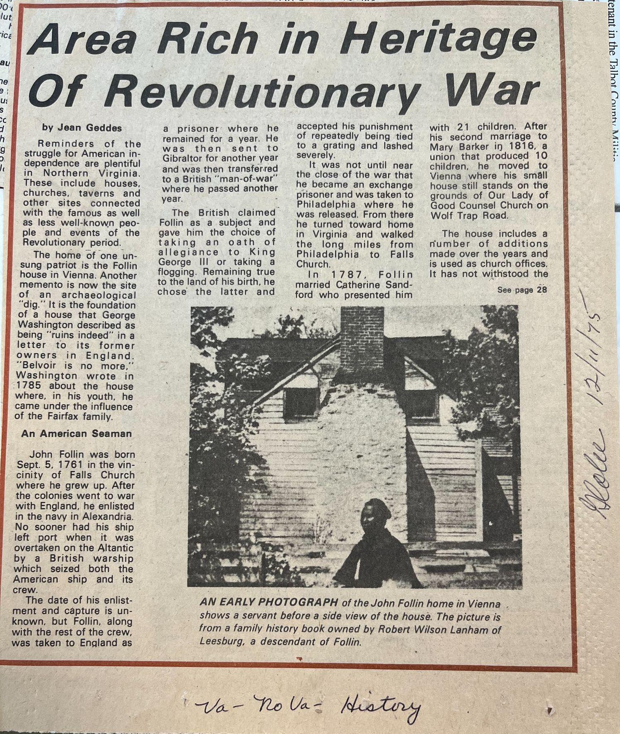
Appendix A

Appendix B

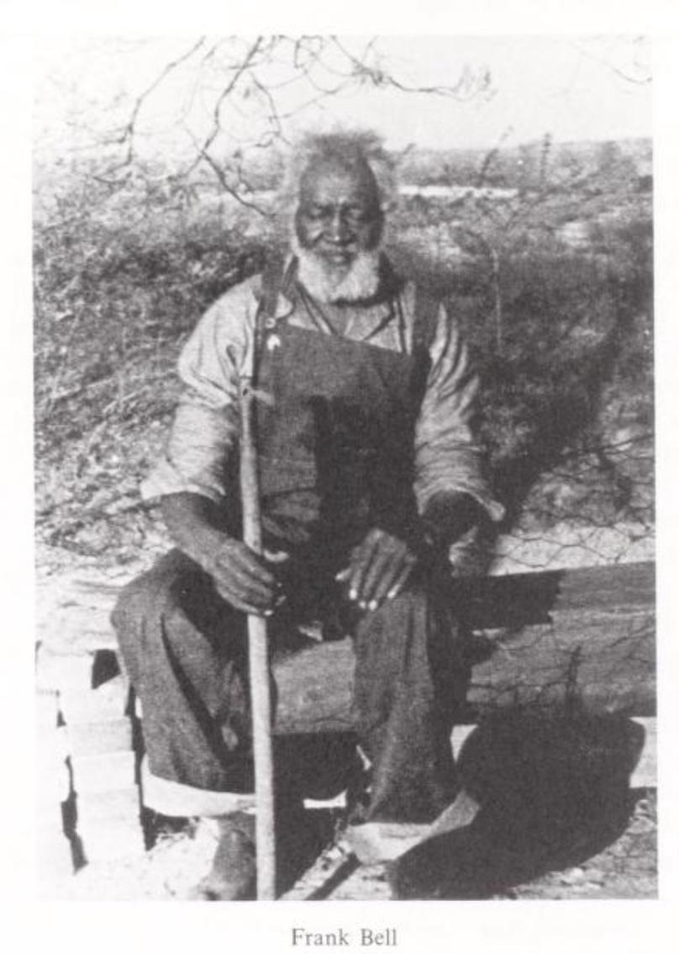

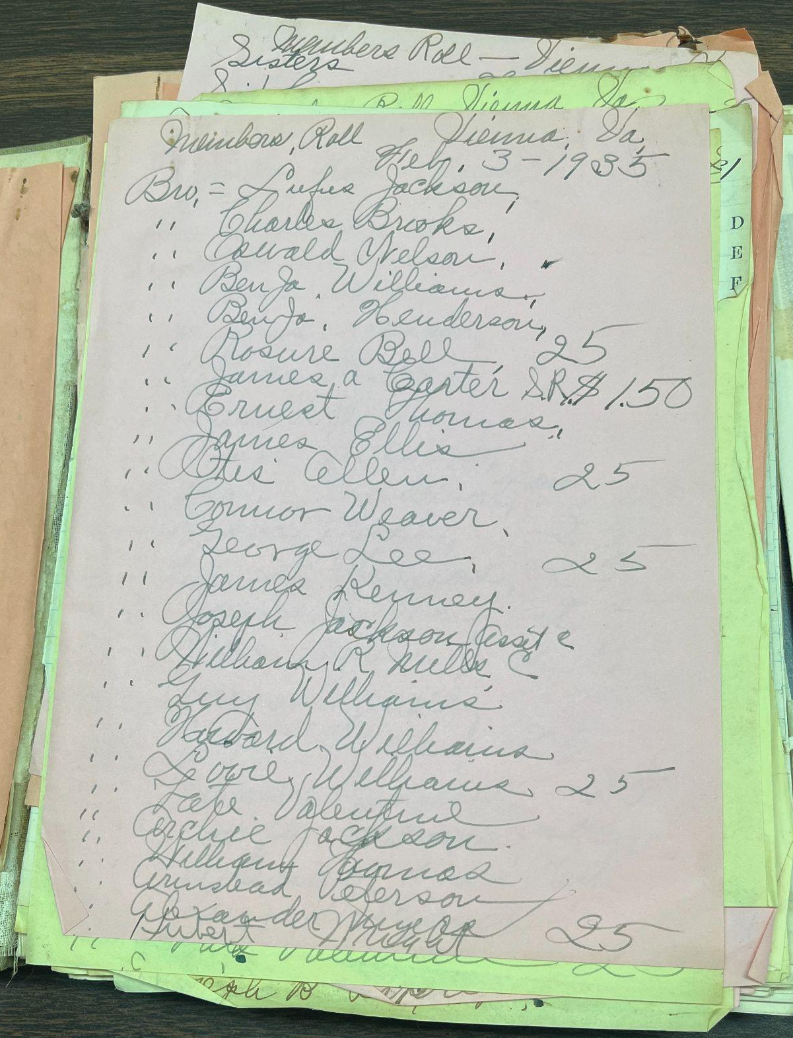
Appendix C

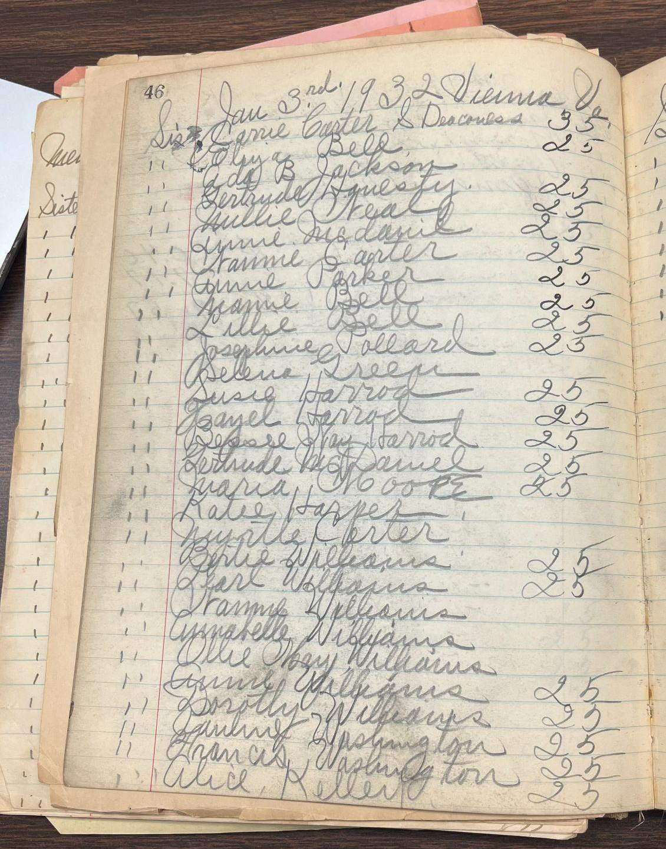

1935 First Baptist Church of Vienna Member Book, Stacy Seay

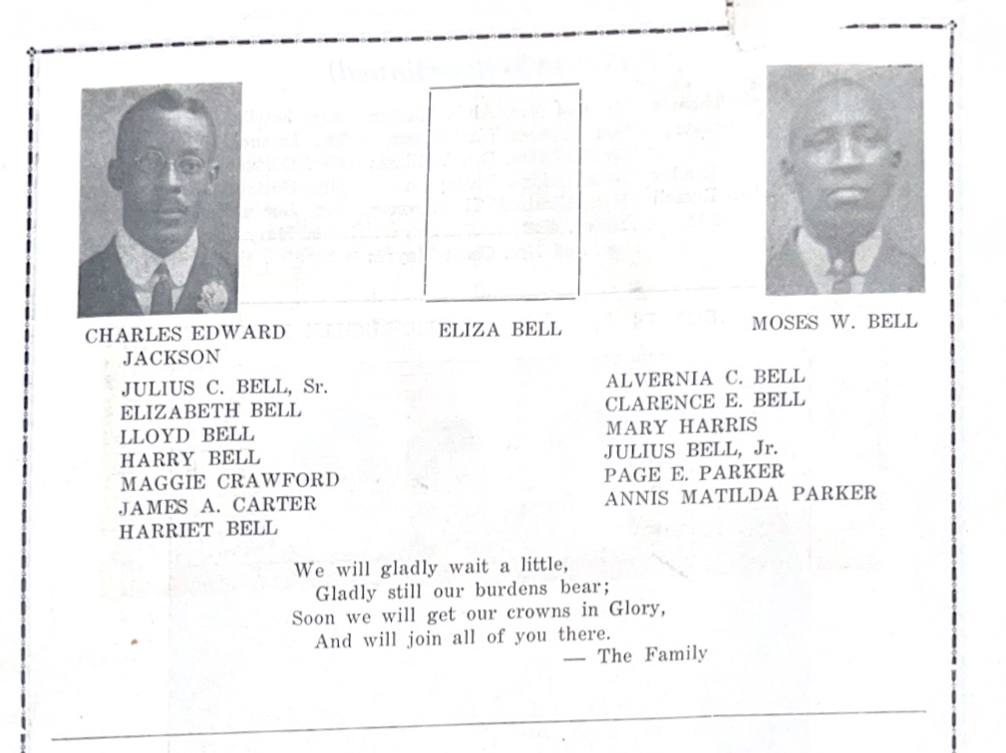
Appendix D

1952 First Baptist Church of Vienna Program Memorial Ad, Stacey Seay

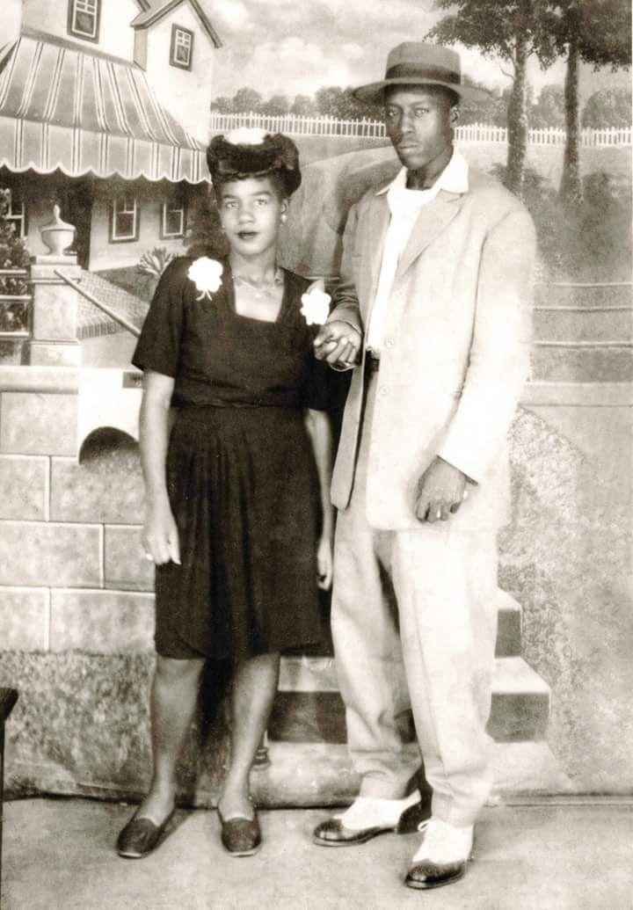
Appendix E

Harriet Bell’s Great Grandson Rosure Bell and his wife Lillian Carter
FindAGrave. “Rosure ‘Boyd’ Bell,” https://www.findagrave.com/memorial/20326891/bel.

Bibliography
Primary Sources
“1st Baptist Church, Vienna, VA. Member Book,” 1935. First Baptist Church of Vienna.
“Commonwealth of Virginia vs. McBrown, George,” April 1874. Box 089, Folder 1874-063.
Fairfax Circuit Court Historic Records.
“Commonwealth of Virginia vs. Strother, James and Follin, Joseph,” November 1867. Box 070,
Folder 1867-371. Fairfax Circuit Court Historic Records.
“Fairfax County Deed Book,” 1867. Book 2317, p. 483-484. Fairfax Circuit Court Historic
Records.
“Fairfax County Deed Book,” 1876. Book V4, p. 180. Fairfax Circuit Court Historic Records.
“Fairfax County Deed Book,” 1892. Book G-5, p.205. Fairfax Circuit Court Historic Records.
Fairfax Herald. “Lodge To Hold Meeting.” October 7, 1933. Volume 35, Number 45. Virginia
Chronicle.
Fairfax Herald. “Vienna.” September 1, 1893. Volume 12, Number 13. Virginia Chronicle.
FindAGrave. “Mary Saville Gusler Rupp,” n.d.
https://www.findagrave.com/memorial/107555026/mary-saville-rupp.
FindAGrave. “Rosure ‘Boyd’ Bell,” n.d. https://www.findagrave.com/memorial/20326891/bel.
First Baptist Church of Vienna. “Church Program,” 1952. First Baptist Church of Vienna.
Geddes, Jane. “Area Rich in Heritage of Revolutionary War.” Fairfax Globe, December 11, 1975.
Henning, August. “As Heard and Seen.” Fairfax Herald, December 16, 1904, Volume 23,
Number 29 edition. Virginia Chronicle.
———. “As Heard and Seen.” Fairfax Herald, May 12, 1905. Volume 23, Number 49. Virginia
Chronicle.
———. “As Heard and Seen.” Fairfax Herald, November 16, 1906. Fairfax Herald, Volume 25,
Number 25. Virginia Chronicle.
Hine, Orrine E. Letter to Samuel Perry Lee, January 24, 1867. NARA Series Number: M1913.
NARA Reel Number: Roll 43, Registered Letters Received, Vol 1, Jan-Mar 1867. U.S. Freedmen’s Bureau Records, 1865-1878. https://www.ancestry.com/search/collections/62309/records/455196?tid=191023536&pid=202600175433&ssrc=pt.
———. Letter to Samuel Perry Lee, February 2, 1867. Roll 075, Letters Sent, Aug 1865-Oct
1868. U.S. Freedmen’s Bureau Records, 1865-1878. https://www.ancestry.com/imageviewer/collections/62309/images/004151197_00954?pId=625337.
———. Letter to Samuel Perry Lee, February 18, 1867. Roll: Roll 043, Registered Letters
Received, Vol 001, Jan-Mar 1867. U.S. Freedmen’s Bureau Records, 1865-1878. https://www.ancestry.com/imageviewer/collections/62309/images/004150376_00717?pId=455413.
———. Letter to Samuel Perry Lee, March 1, 1867. Roll: Roll 075, Letters Sent, Aug 1865-Oct
1868. U.S. Freedmen’s Bureau Records, 1865-1878. https://www.ancestry.com/discoveryui-content/view/625340:62309?tid=&pid=&queryid=7884e3d6-34ed-4990-9354-40020fcdd5e2&_phsrc=BfC123&_phstart=successSource.
———. Letter to Samuel Perry Lee, March 18, 1867. Roll 075, Letters Sent, Aug 1865-Oct
1868. U.S. Freedmen’s Bureau Records, 1865-1878. https://www.ancestry.com/imageviewer/collections/62309/images/004151197_00960?pId=625337.
“Inventory of John Follin’s Property in 29 June 1841,” n.d. Fairfax Circuit Court Historic
Records.
Issue of News. “Obituary.” April 15, 1967. Newspaper Archive.
Orrine E., Hine. Letter to Samuel Perry Lee, April 2, 1867. NARA Series Number: M1913.
NARA Reel Number: Roll 42, Registers of Letters Received, Vol 2, Mar 1867-Apr 1868. National Archives and Records Administration (NARA). https://www.ancestry.com/search/collections/62309/records/448516?tid=&pid=&queryId=d2163808-1996-49bb-ba81-795925df2d9b&_phsrc=ddg2200&_phstart=successSource.
Perdue, Charles L., Thomas E. Barden, Robert K. Phillips, and Virginia Writers’ Project. Weevils
in the Wheat: Interviews with Virginia Ex-Slaves. Charlottesville: University Press of Virginia, 1976. http://archive.org/details/weevilsinwheatin00perd.
Red Bank Register. “Mrs. Elizabeth Saul.” September 5, 1940.
https://www.digifind-it.com/redbank/data/newspapers/register/reg-1878-1969/1940/1940-09-05.pdf.
U.S. Census Bureau. “1850 Federal Census - Slave Schedules,” 1850. NARA Microform
Publication: M432; Title: Seventh Census of the United States, 1850; Record Group: Records of the Bureau of the Census; Record Group Number: 29. National Archives and Records Administration (NARA). https://www.ancestry.com/search/collections/8055/records/92713466?tid=191023536&pid=202600175433&ssrc=pt.
———. “1860 United States Federal Census – Slave Schedules,” 1860. Series Number: M653;
Record Group: Records of the Bureau of the Census; Record Group Number: 29.
———. “1870 United States Federal Census,” 1870. Census Place: Providence, Fairfax,
Virginia; Roll: M593_1645; Page: 372B. National Archives and Records Administration (NARA). https://www.ancestry.com/search/collections/7163/records/39161073?tid=191023536&pid=202600175433&ssrc=pt.
———. “1880 United States Federal Census,” n.d. Census Place: Providence, Fairfax, Virginia.
Roll: 1364; Page: 374d; Enumeration District: 038. National Archives and Records Administration (NARA). https://www.ancestry.com/search/collections/6742/records/42694916?tid=191023536&pid=202600175433&ssrc=pt.
Washington Post. “News of Fraternal Organizations.” November 21, 1926. ProQuest Historical
Newspapers.
West, William. West, William, 1971, 1971. Northern Virginia oral history project collection
(C0030) Series 1: Northern Virginia Community, 1958-1990, Box 13. Special Collections Research Center.
———. West, William, October 2, 1974, October 2, 1974. Series 1: Northern Virginia
Community, 1958-1990 West, William , October 2, 1974, Box 12. Special Collections Research Center.
———. West, William, September 17, 1974, September 17, 1974. Northern Virginia oral history
project collection (C0030) Series 1: Northern Virginia Community, 1958-1990, Box 13. Special Collections Research Center.

Secondary Sources
American Battlefield Trust. “John Singleton Mosby,” n.d.
https://www.battlefields.org/learn/biographies/john-singleton-mosby.
Camp, Stephanie M. H. Closer to Freedom: Enslaved Women and Everyday Resistance in the
Plantation South. Chapel Hill: The University of North Carolina Press, 2004.
Center for Mason Legacies. “Cyrus F. Carter.” Fairfax County African American History
Inventory. Accessed December 15, 2024. https://fairfaxaahi.centerformasonslegacies.com/items/show/84.
Doyle, Nora. Maternal Bodies: Redefining Motherhood in Early America. Chapel Hill: The
University of North Carolina Press, 2018.
Edmonston, Gabriel. A Genealogical History of the Follin Family in America. 1128 Twelfth St. N. W., Washington, D.C.: G. Edmonston, 1911.
Farmer-Kaiser, Mary. Freedwomen and the Freedmen's Bureau: Race, Gender, and Public Policy
in the Age of Emancipation. United States: Fordham University Press, 2010.
First Baptist Church of Vienna. “Our History,” n.d. https://www.fbcv.org/our-history.
King, Wilma. The Essence of Liberty: Free Black Women during the Slave Era. Columbia, Mo.:
University of Missouri Press, 2006.
Myers, Amrita Chakrabarti. Forging Freedom: Black Women and the Pursuit of Liberty in
Antebellum Charleston. 1st ed. Chapel Hill: The University of North Carolina Press, 2011. https://doi.org/10.5149/9780807869093_myers.
New Union Baptist Church. “Our History,” n.d. https://www.newunionbc.org/our-history.
Pargas, Damian Alan. "Work and slave family life in antebellum northern Virginia." Journal of
Family History 31, no. 4 (2006): 335-357.
Schweninger, Loren. “Property Owning Free African-American Women in the South,
1800-1870.” Journal of women’s history 1, no. 3 (1990): 13–44.
Smith, Suzanne E. To Serve the Living: Funeral Directors and the African American Way of
Death. Harvard University Press, 2010.
Vaughn, Curtis L. “Freedom Is Not Enough: African Americans in Antebellum Fairfax County,”
PhD diss., (George Mason University, 2008).
Williams, Kidada E. They Left Great Marks on Me: African American Testimonies of Racial
Violence from Emancipation to World War I. New York: New York University Press, 2012.

Jane Geddes, “Area Rich in Heritage of Revolutionary War,” Fairfax Globe, December 11, 1975.
Placemaking is the process through which one gives meaning or context to a space. For example, by purchasing a plot of land, building a house on it, and passing it down to your children, you transform that geography of dirt, grass, and trees, into an heirloom and generational wealth for your family.
Gabriel Edmonston, A Genealogical History of the Follin Family in America (G. Edmonston, 1911), 129.
Charles L. Perdue, Thomas E. Barden, Robert K. Phillips, and Virginia Writers’ Project, Weevils in the Wheat : Interviews with Virginia Ex-Slaves (University Press of Virginia, 1976), 23-27.
Thavolia Glymph, Out of the House of Bondage: The Transformation of the Plantation Household, 1st ed. (Cambridge University Press, 2003). https://doi.org/10.1017/CBO9780511812491, 36.
U.S. Census Bureau. “1850 Federal Census - Slave Schedules,” 1850. NARA Microform Publication: M432; Record Group Number: 29. National Archives and Records Administration (NARA).
Curtis L. Vaughn, “Freedom Is Not Enough: African Americans in Antebellum Fairfax County,” PhD diss., (George Mason University, 2008), 3.
Vaughn, “Freedom Is Not Enough,” 9.
Edmonston, A Genealogical History of the Follin Family in America, 129.
Edmonston, A Genealogical History of the Follin Family in America, 129.
Glymph, Out of the House of Bondage, 134
Nora Doyle, Maternal Bodies: Redefining Motherhood in Early America (The University of North Carolina Press, 2018).
Stephanie M. H. Camp, Closer to Freedom: Enslaved Women and Everyday Resistance in the Plantation South (The University of North Carolina Press, 2004).
Damian Alan Pargas, "Work and slave family life in antebellum northern Virginia," Journal of Family History 31, no. 4 (2006): 344.
U.S. Census Bureau. “1860 United States Federal Census – Slave Schedules,” 1860. Series Number: M653; Record Group: Records of the Bureau of the Census; Record Group Number: 29.
Camp, Closer to Freedom, 37, 95.
“Inventory of John Follin’s Property in 29 June 1841,” Fairfax Circuit Court Historic Records.
Perdue, Weevils in the Wheat, 23-27.
Perdue, Weevils in the Wheat, 23.
Kidada E. Williams, They Left Great Marks on Me: African American Testimonies of Racial Violence from Emancipation to World War I (New York University Press, 2012), 21.
U.S. Census Bureau. “1870 United States Federal Census,” 1870. Census Place: Providence, Fairfax, Virginia; Roll: M593_1645; Page: 372B. National Archives and Records Administration (NARA).
“Fairfax County Deed Book,” 1876. Book V4, p. 180. Fairfax Circuit Court Historic Records.
Loren Schweninger,“Property Owning Free African-American Women in the South, 1800-1870.” Journal of women’s history 1, no. 3 (1990): 29.
U.S. Census Bureau. “1880 United States Federal Census,” Census Place: Providence, Fairfax, Virginia; Roll: 1364; Page: 374d; Enumeration District: 038. National Archives and Records Administration (NARA).
“Fairfax County Deed Book,” 1867. Book 2317, p. 483-484. Fairfax Circuit Court Historic Records.
“Cyrus F. Carter,” Fairfax County African American History Inventory, accessed December 15, 2024, https://fairfaxaahi.centerformasonslegacies.com/items/show/84.
William West, September 17, 1974, September 17, 1974. Northern Virginia oral history project collection (C0030) Series 1: Northern Virginia Community, 1958-1990, Box 13. Special Collections Research Center.
“Fairfax County Deed Book,” 1876. Book V4, p. 180. Fairfax Circuit Court Historic Records.
Orrine E., Hine. Letter to Samuel Perry Lee, April 2, 1867. NARA Series Number: M1913; NARA Reel Number: Roll 42, Registers of Letters Received, Vol 2, Mar 1867-Apr 1868. National Archives and Records Administration (NARA).
Conversations and collaboration with Stacey Seay, First Baptist Church of Vienna Pastoral Assistant and descendant of George “Mack” Brown; “1st Baptist Church, Vienna, VA. Member Book,” 1935. First Baptist Church of Vienna.
“Fairfax County Deed Book,” 1892. Book G-5, p.205. Fairfax Circuit Court Historic Records.
Issue of News. “Obituary.” April 15, 1967. Newspaper Archive; Red Bank Register. “Mrs. Elizabeth Saul.” September 5; FindAGrave. “Mary Saville Gusler Rupp,” n.d. https://www.findagrave.com/memorial/107555026/mary-saville-rupp.
Suzanne Smith, To Serve the Living: Funeral Directors and the African American Way of Death (Harvard University Press, 2010), 42.
Fairfax Herald. “Vienna.” September 1, 1893. Volume 12, Number 13. Virginia Chronicle.
New Union Baptist Church. “Our History,” n.d. https://www.newunionbc.org/our-history
Henning, August. “As Heard and Seen.” Fairfax Herald, December 16, 1904, Volume 23, Number 29 edition. Virginia Chronicle.
Henning, August. “As Heard and Seen.” Fairfax Herald, November 16, 1906. Fairfax Herald, Volume 25, Number 25. Virginia Chronicle.
Smith, To Serve the Living, 26.
“Fairfax County Deed Book,” 1892. Book G-5, p.205. Fairfax Circuit Court Historic Records.
William West, September 17, 1974, September 17, 1974. Northern Virginia oral history project collection (C0030) Series 1: Northern Virginia Community, 1958-1990, Box 13. Special Collections Research Center.
Henning, August. “As Heard and Seen.” Fairfax Herald, May 12, 1905. Volume 23, Number 49. Virginia Chronicle.
Fairfax Herald. “Lodge To Hold Meeting.” October 7, 1933. Volume 35, Number 45. Virginia Chronicle.
Washington Post. “News of Fraternal Organizations.” November 21, 1926. ProQuest Historical Newspapers.
Catherine Clinton, “Bloody Terrain: Freedwomen, Sexuality and Violence During Reconstruction.” The Georgia Historical Quarterly 76, no. 2 (1992): 313–32.
“Commonwealth of Virginia vs. Strother, James and Follin, Joseph,” November 1867. Box 070, Folder 1867-371. Fairfax Circuit Court Historic Records.
Hine Letter to Lee, January 24, 1867.
U.S. Census Bureau. “1870 United States Federal Census,” 1870. Census Place: Providence, Fairfax, Virginia; Roll: M593_1645; Page: 372B. National Archives and Records Administration (NARA).
Orrine E. Hine, Letter to Samuel Perry Lee, January 24, 1867. NARA Series Number: M1913; NARA Reel Number: Roll 43, Registered Letters Received, Vol 1, Jan-Mar 1867. U.S. Freedmen’s Bureau Records, 1865-1878.
American Battlefield Trust. “John Singleton Mosby,” n.d. https://www.battlefields.org/learn/biographies/john-singleton-mosby.
Orrine E. Hine, Letter to Samuel Perry Lee, February 2, 1867. Roll 075, Letters Sent, Aug 1865-Oct 1868. U.S. Freedmen’s Bureau Records, 1865-1878.
Orrine E. Hine, Letter to Samuel Perry Lee, February 18, 1867. Roll: Roll 043, Registered Letters Received, Vol 001, Jan-Mar 1867. U.S. Freedmen’s Bureau Records, 1865-1878.
Hine Letter to Lee, February 2, 1867.
Orrine E. Hine Letter to Samuel Perry Lee, March 18, 1867. Roll 075, Letters Sent, Aug 1865-Oct 1868. U.S. Freedmen’s Bureau Records, 1865-1878.
Hine Letter to Lee, March 18, 1867.
Orrine E. Hine Letter to Samuel Perry Lee, March 1, 1867. Roll: Roll 075, Letters Sent, Aug 1865-Oct 1868. U.S. Freedmen’s Bureau Records, 1865-1878.
“Commonwealth of Virginia vs. McBrown, George,” April 1874. Box 089, Folder 1874-063. Fairfax Circuit Court Historic Records.
Her descendants and family have joined a class of Black Americans whose lineage is connected to slavery who preserve their memory within the family and often in physical objects. See Tiya Miles, All That She Carried: The Journey of Ashley's Sack, a Black Family Keepsake (Random House Publishing Group, 2021).
Stacey Seay, First Baptist Church of Vienna; “Church Program,” 1952. First Baptist Church of Vienna.

